**Experiment – 1.2**

**Student Name:** Paras Guglani  **UID:** 20BCS9403

**Branch:** CSE **Section/Group:** 20BCS_KRG_DM-G1

**Semester:** 06 **Date of Performance:** 24/02/2023

**Subject Name:** Mobile Application Development Lab  **Subject Code:** 20CSP-356

**1. Aim/Overview of the practical:**

To design an android application to display Hello World.

**2.** **Task to be done:**

Create an application that takes the name from a "Text Box" and shows a "Hello" message along with the name entered in the "Text Box" when the user clicks the "OK" button.

**3.** **System Requirements:**

The required tools to develop Android applications are open source and can be downloaded from the Web. Following is the list of software's you will need before you start your Android application programming.

* Android Studio .exe file
* Java JDK5 or later version
* Java Runtime Environment (JRE) 6 Android Studio

**4.** **Script and Output:**

Android Studio is the official IDE for android application development. It works based on IntelliJ IDEA, you can download the latest version of android studio from Android Studio 2.2 Download.

**STEP 1:** Open Android Studio and select your Template and Activity.

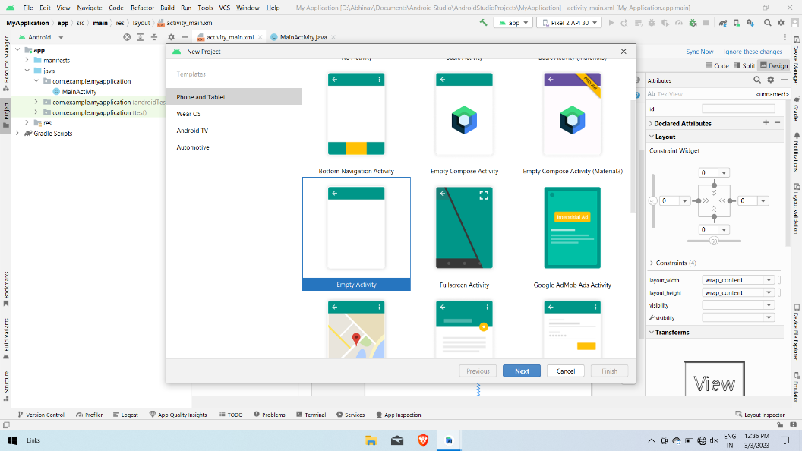

**Step 2:** Name your project and select your language and minimum SDK.

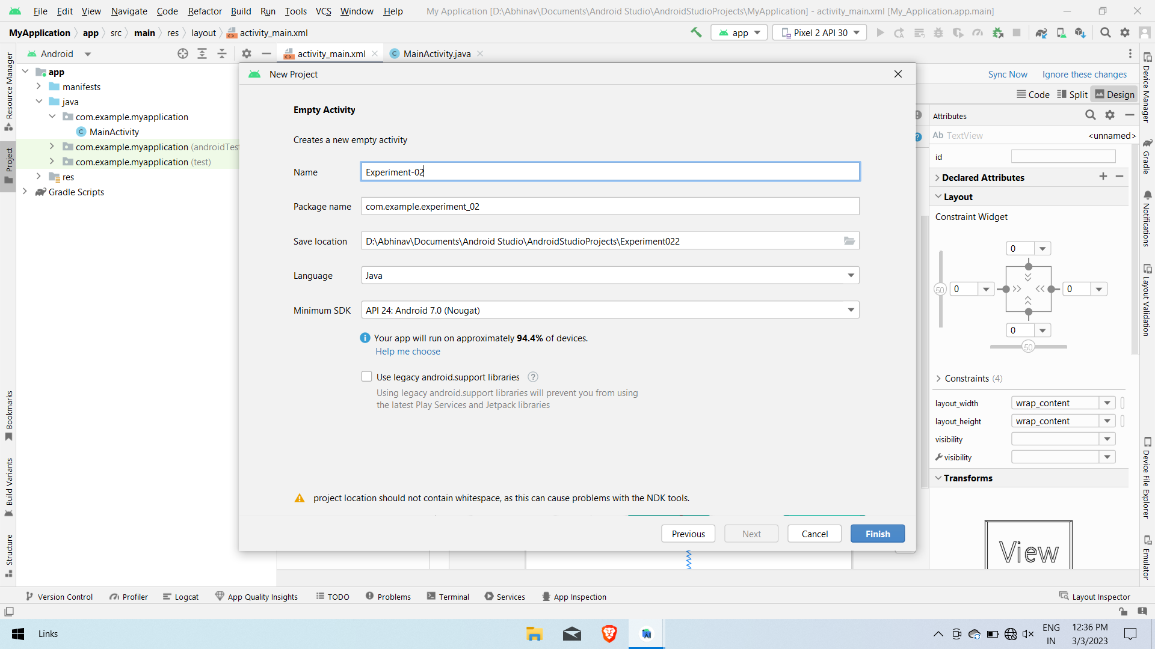

**STEP 3:** You can start building your application in xml file by just drag and drop or by writing your code.

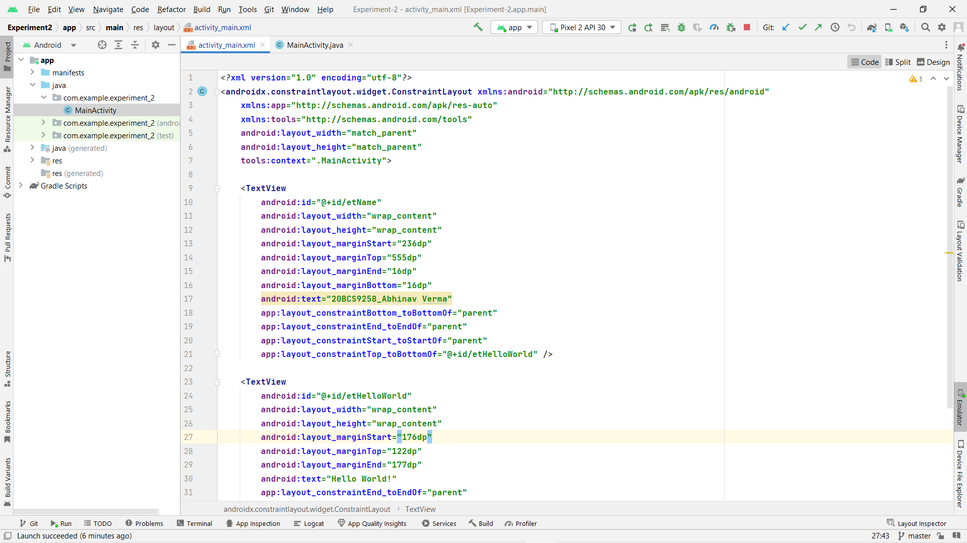

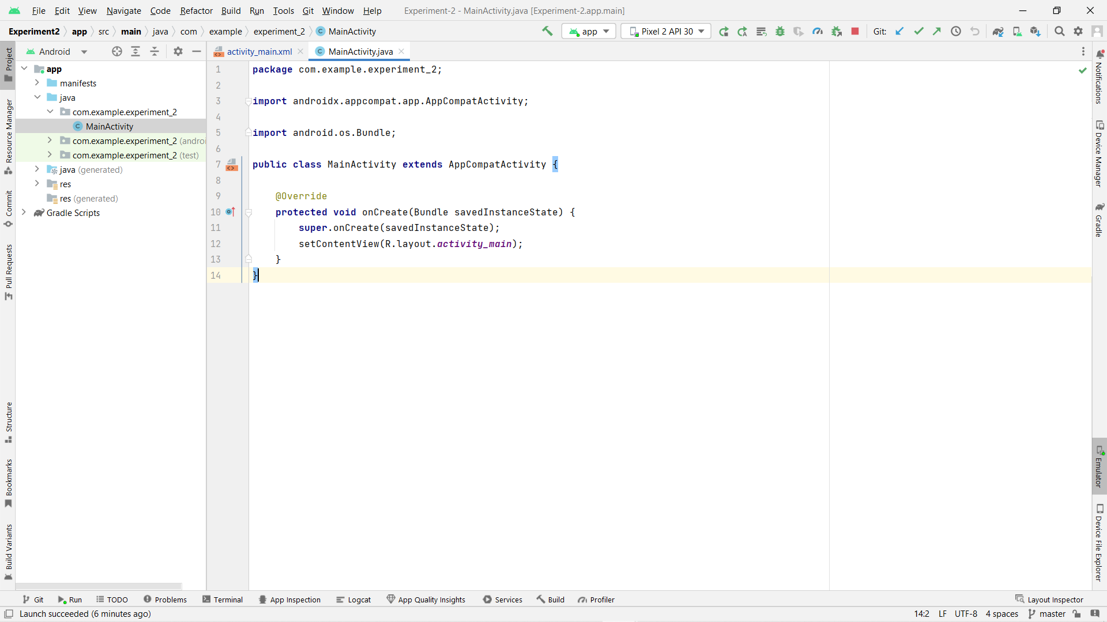

**Step 4:** You will get lots of option for building your application like Palette (you can drag and drop from here) Attributes.

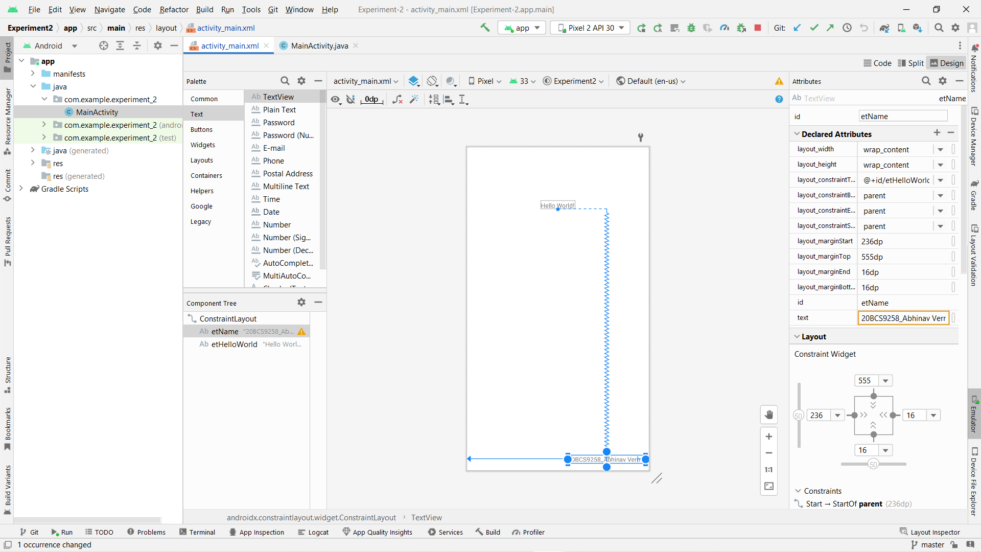

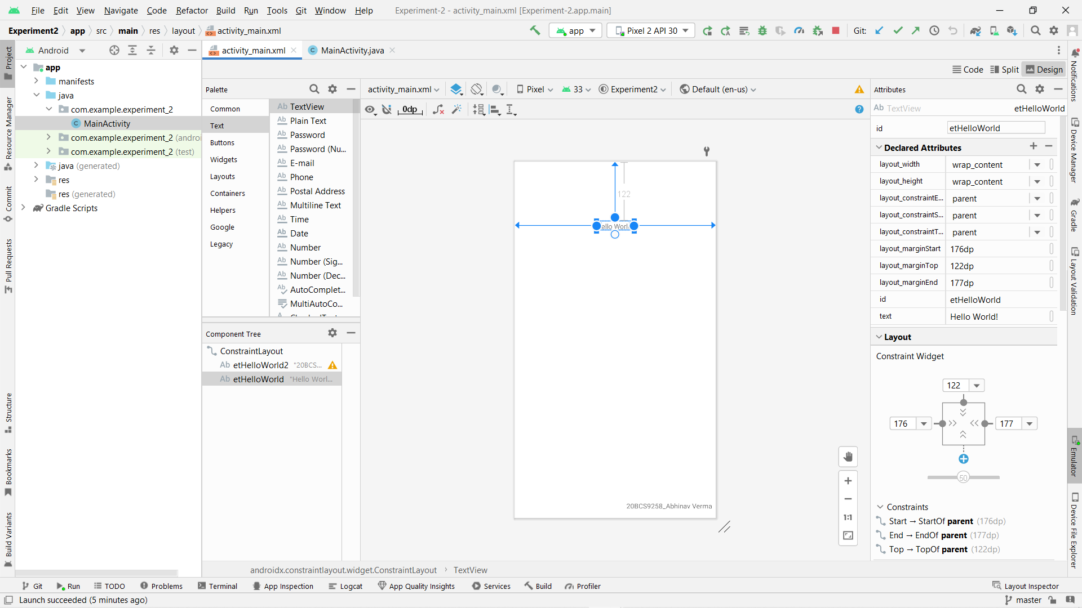

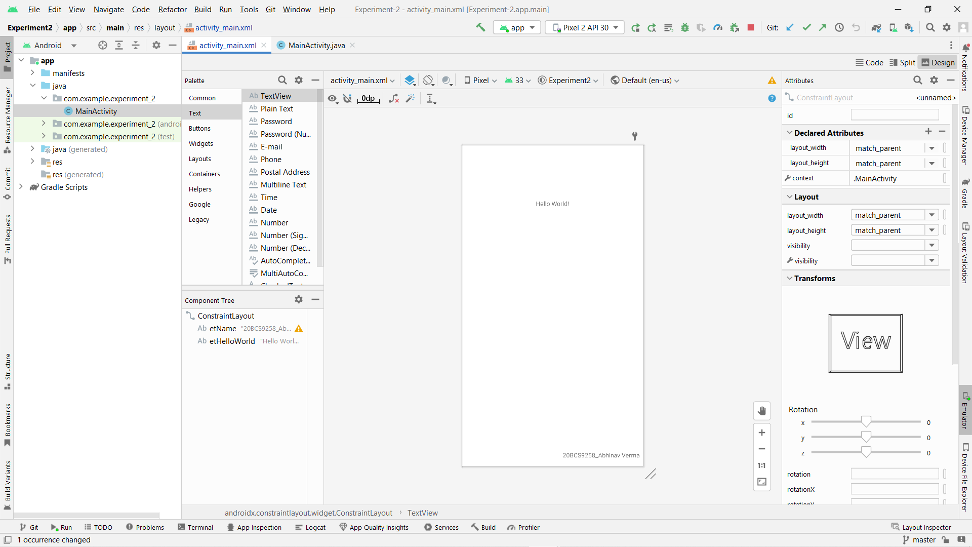

**STEP 5:** Here is the final output.

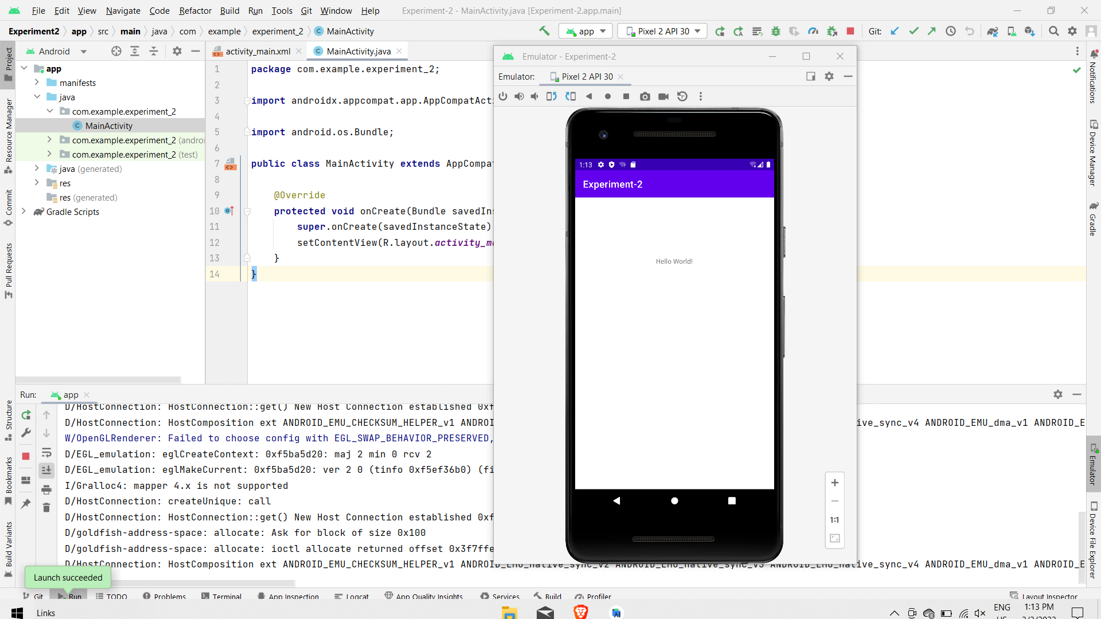

Now, our Hello World project is complete and working.